Tableau Lab

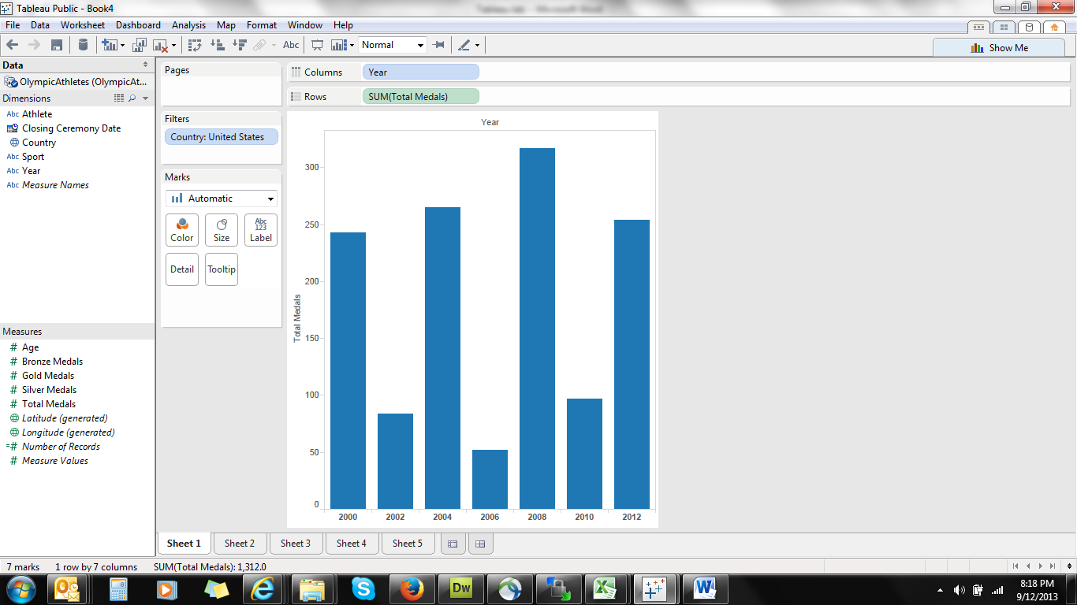

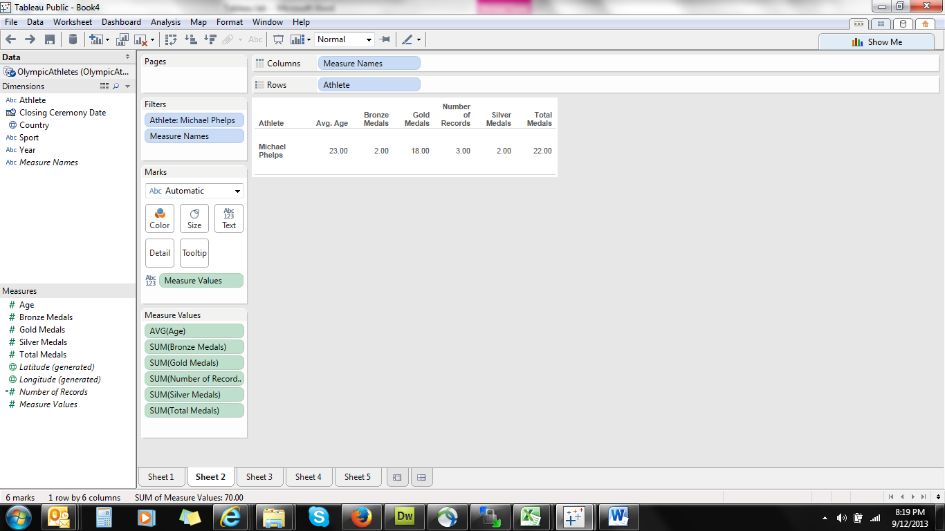

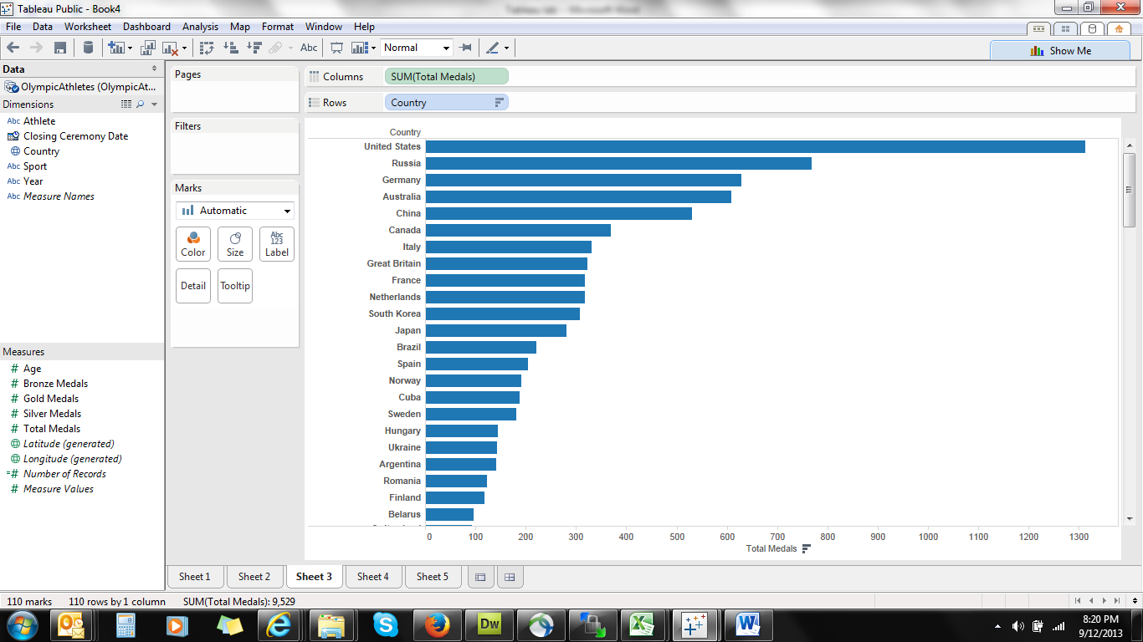

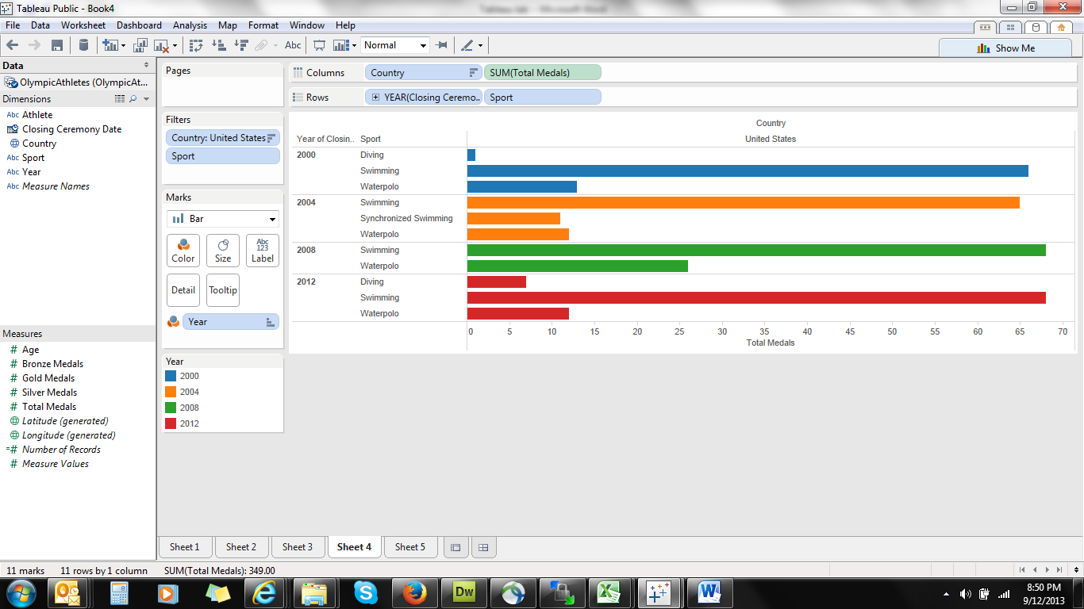

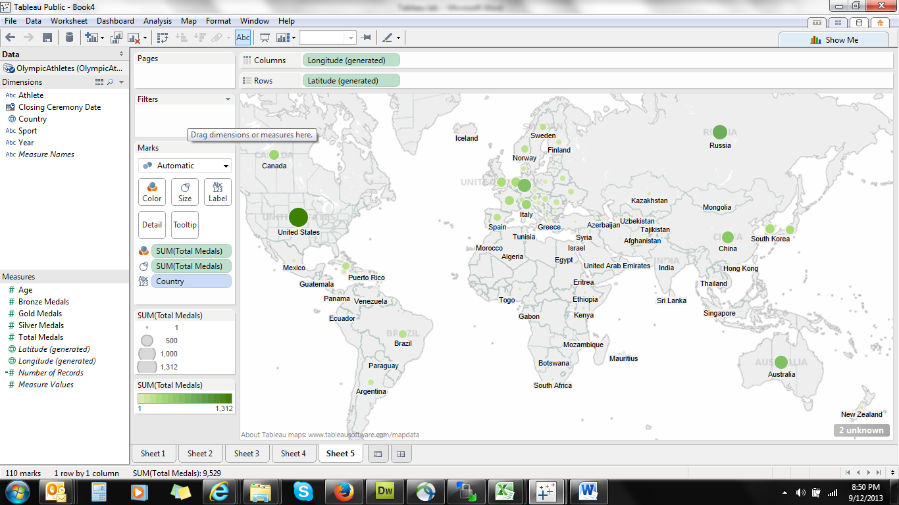

Tableau lab

1. How many medals have athletes won since the 2000 Games?
2. How has the number of gold medals changed over time?
3. Which countries have won the most number of medals in swimming?
4. How many each of gold, silver and bronze medals has Michael Phelps won?
5. Create a map view of the total medals won by each country
6. Design 3 different views of data of your own design.

